Summary on PUBG Dataset

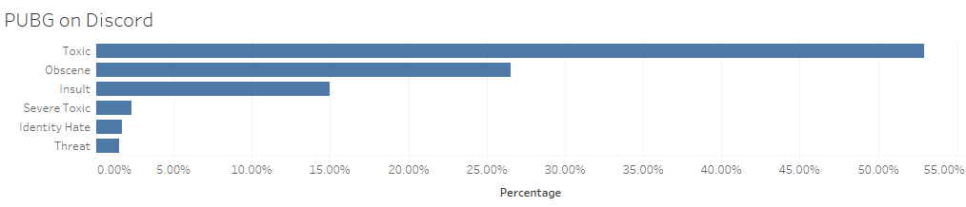

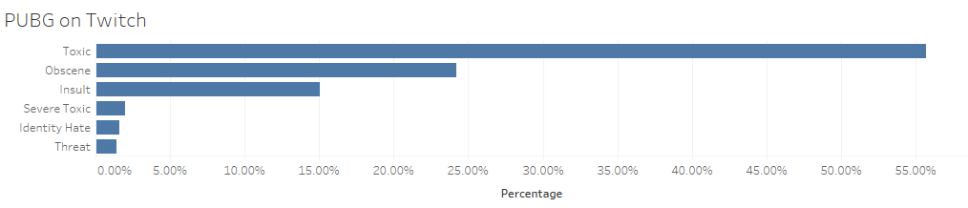

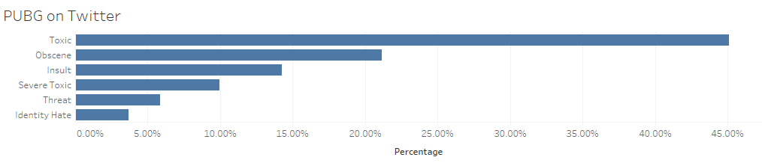

As clearly shown in the pictures above, we have the following conclusions:

1. On all three platforms, the two most common types of toxicity in the gaming environment are “obscene” and “insult”, which include words about sexual organs and violence.
2. On Discord, a larger percentage of toxic comments are “obscene”, and Twitch shows the least percentage of “obscene”.
3. The distribution pattern of toxicity on Twitter is quite different from the other two. There are considerably more “severe toxic”, “threat”, “identity hate” comments.
4. When people get angry and toxic on gaming topics, only a small percentage of them will express “identity hate” and “threat”.
5. “Severe toxic” and “threat” comments usually include words about death and severe crime.
6. Generally, the rate of occurrence of toxic comments of each type is negatively correlated to the extent of toxicity. Namely, the more severe the type of toxicity is, the less common it occurs in the people’s comments.
7. Compared to LoL, a larger proportion of toxic comments are severe.